# Linking Wallet to MegaCapital.io

Video

Linking your wallet to Megacapital.io is easy!

1. Go to the Megacapital.io. Click on login.

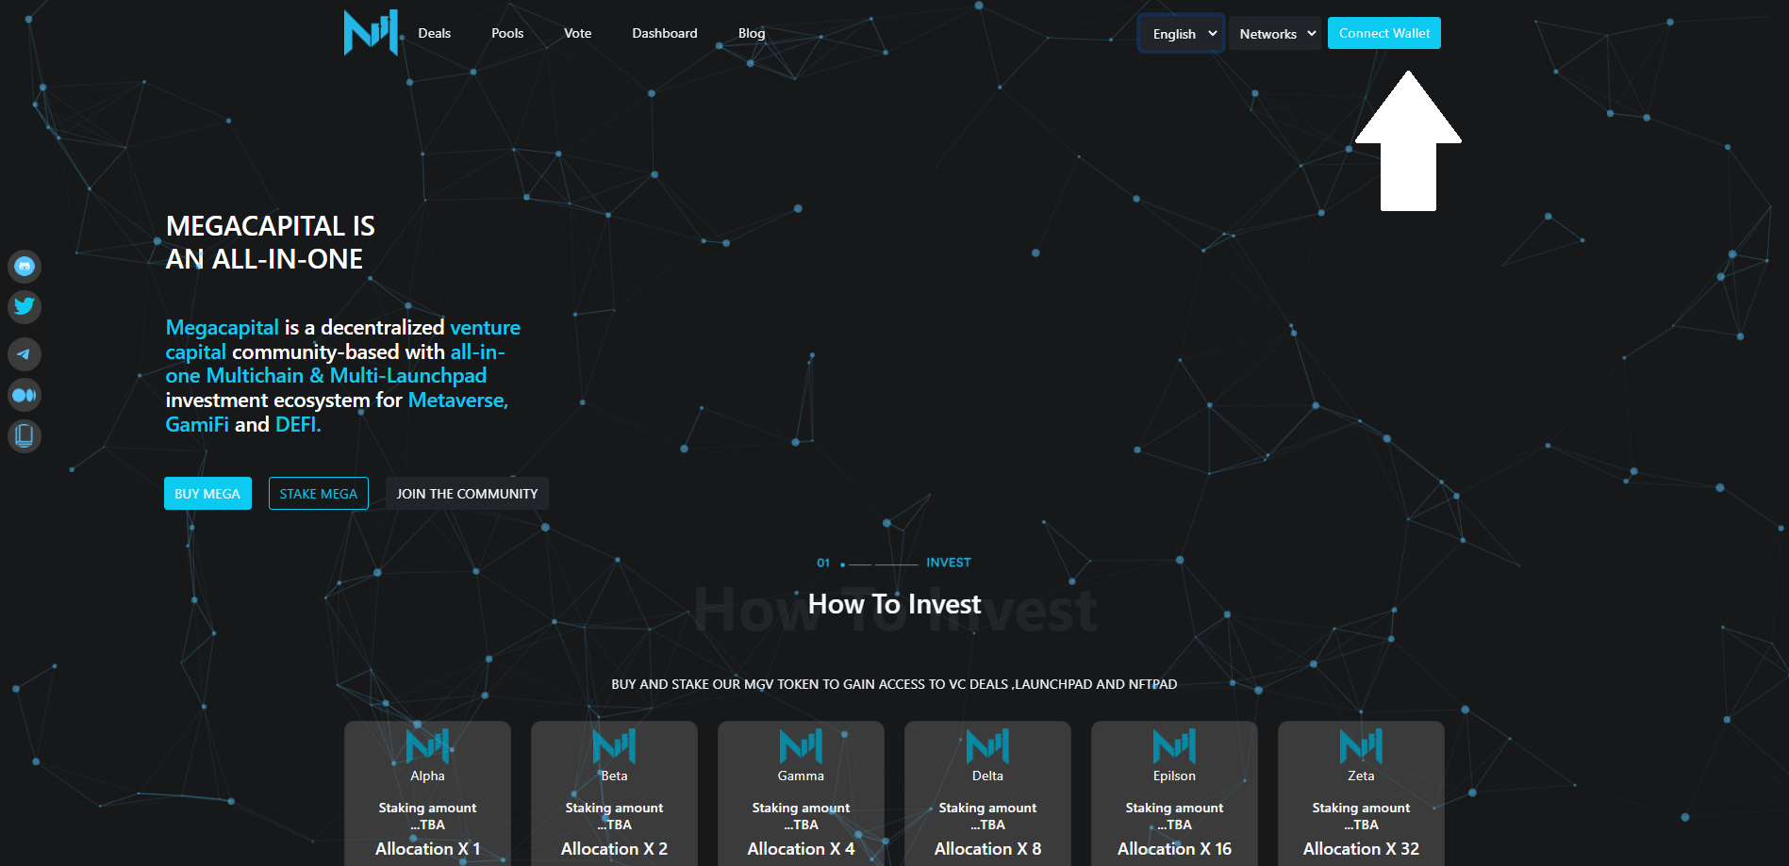

2. Now, click on Unlock wallet.

3. Choose Metamask from the available options.

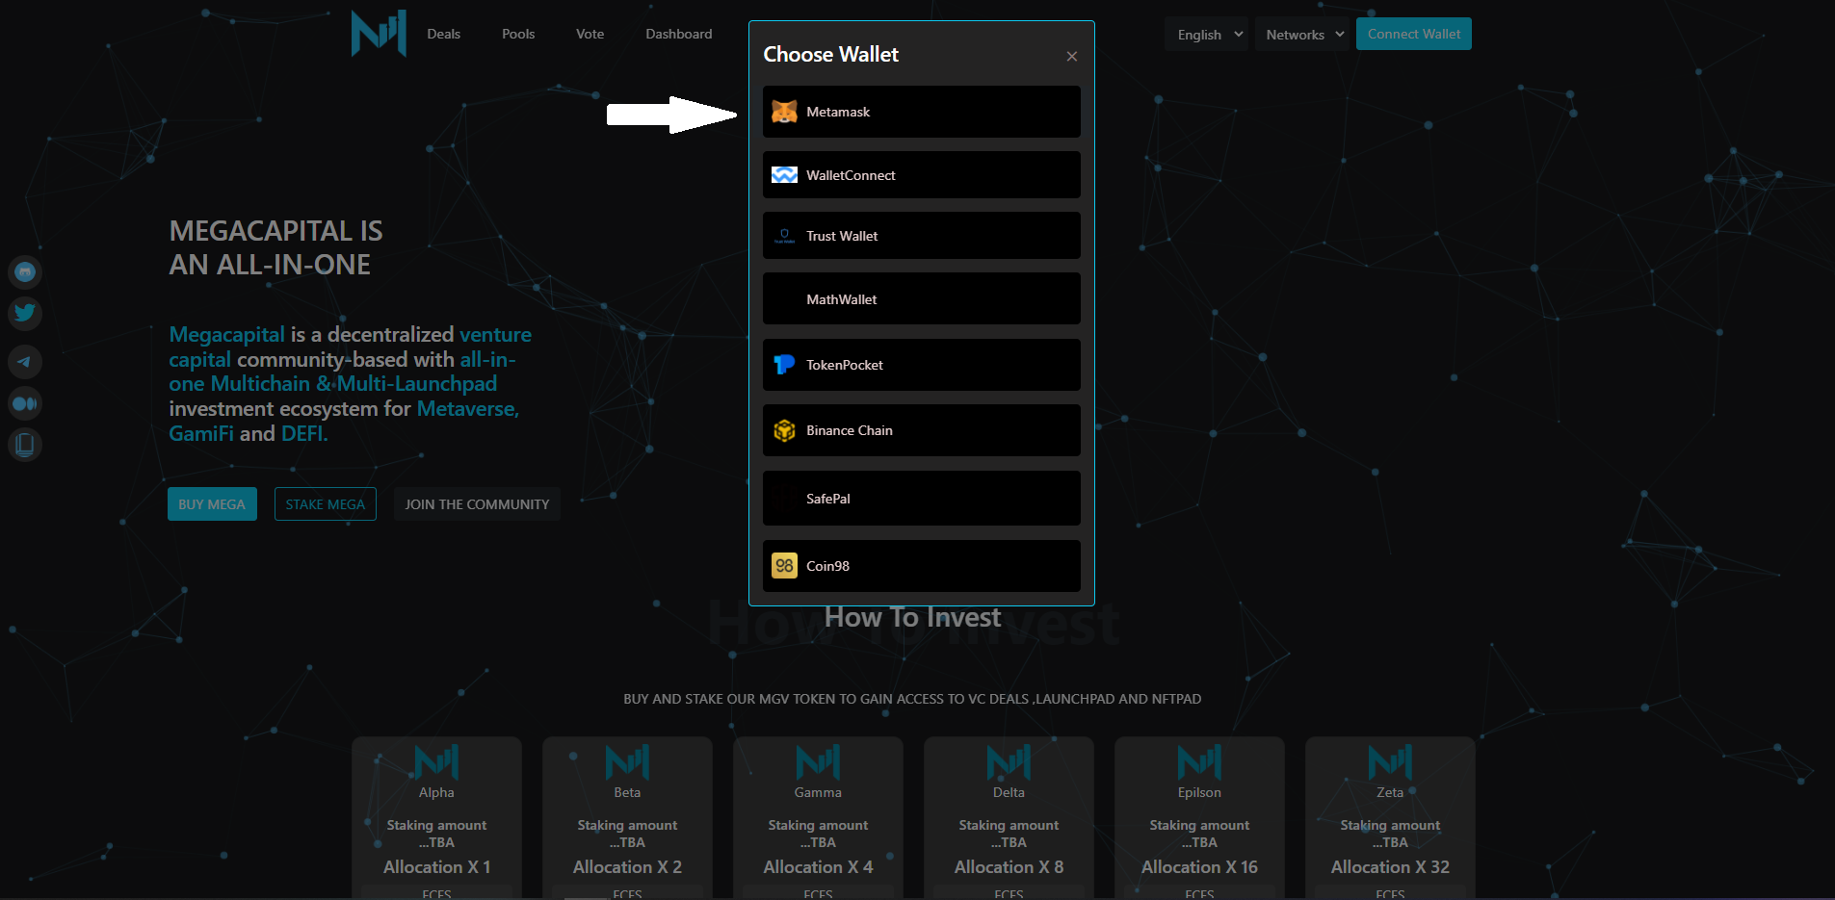

4. Enter your password into MetaMask to unlock your wallet and click on Unlock.

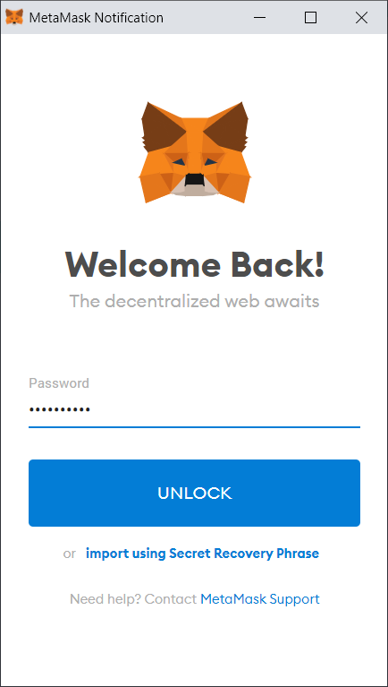

5. Next, click on Sign.

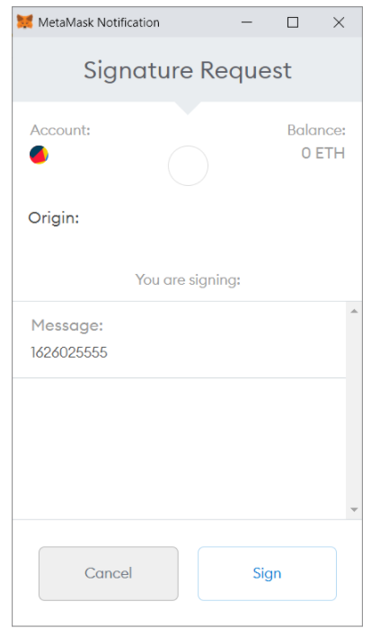

6. Now you are logged into Megacapital.io!